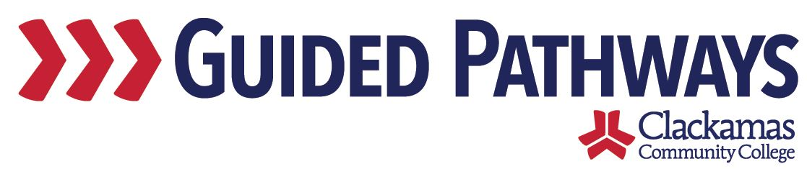
Guided Pathways Leadership Taskforce
Meeting Notes
April 2, 2018
2:00 – 3:30 p.m.

- Follow up on previous commitments
Previous commitments were reviewed.

- Example Infographic
Lisa Anh asked for additional information about what type of infographic we would like to see. There are three different audiences: students, faculty/staff, and community. Each of these audiences have different needs. The infographic should capture the why. It should include data – such as completion rates and time to completion. The information that was shared at Winter Inservice would be useful.

There was conversation around whether we want to focus on the retention piece of keeping/retaining students or whether we want to focus on the completion piece. Dustin said that retention huge, but that might not mean as much to the students or community. Tara pointed out that we don’t have to call it retention – the messaging could be different. The topic of excess credits was discussed. How many dollars are spent on excess credits? How many of our students transfer to PSU with more credits than they need? Max asked if it would be possible to use comparative data – using data from other institutions that are further along on guided pathways and the shifts that they have seen. This could provide context around numbers.

It was agreed that this first infographic should be geared toward faculty/staff. The data from Winter Inservice – retention of students and students not meeting completion goal – should be used, to help provide a consistent message. The excess credit and money pieces could come later, as part of the community and/or student facing infographic.

Nora said that she believes 70-80% of faculty have bought into guided pathways. She said she’s not sure we need to sell it, so much as focus on the how. Tara said that telling the story to keep it at the forefront of people’s minds around the why will resonate when people have interactions with students.

The importance of being aligned in our messaging was discussed. Lisa Anh will connect with the communication workgroup. She’ll share an example infographic at the May meeting. Tara shared that Lisa Anh will be joining the Guided Pathways Taskforce as a regular member.

Tara showed the proof of the guided pathways bookmark.
The audience for the bookmark is faculty/staff. A generic email account (guidedpathways@clackamas.edu) will be provided. Some feedback:
- Change “how are we building the path?” to “what’s happening now to build the path?”
- Take out multi-year in the first paragraph
- Remove “concept” from the second sentence of the second paragraph
- Change the numbering to bullets and make alphabetical
- Add something about curriculum maps in the Educational Focus Areas

Tara played the CeCe Clackamas video: https://www.youtube.com/watch?v=tRrAmzTOE6Q

Commitments:
- Lisa Anh committed to connecting with the communication workgroup.
- Lisa Anh committed to sharing an example infographic at the May meeting.
- Everyone committed to providing their edits/comments on the bookmark to Tara by April 11.

- Draft timeline document
Max shared an update on the work of the project managers, including the Guided Pathways Implementation Timeline.
This timeline is currently for internal use, but the project managers have discussed eventually creating a document that is sent to the rest of the College. The cover page describes what each of the workgroups does and who is in charge at the coordinating level. There is a general overview timeline, as well as more detailed timelines for each of the workgroups. The last page of the document includes a list of work outside of the existing workgroups. Taskforce members offered suggestions for items to add or change to this list.

Communication of the timeline was discussed, including the idea of presenting as part of Fall Inservice.

The idea of having a design subgroup was discussed, with the suggestion that it could be a part of the communications subgroup. There was conversation about communication, such as the Oregon Pathways funds that we’ve recently been awarded. What can those funds be used for? Who is attending the upcoming institute?

Commitments:
- Tara committed to follow up with David around the Oregon Success Center Pathways Cohort 1 funds and discussing who should attending the institute in May.

- Workgroup updates
Brief workgroup updates were provided by each of the project leads. Dustin reported that the Collaborative Advising subgroup is meeting next week. They have four more meetings scheduled this term. Sue reported that the Curriculum subgroup has met once since Winter Inservice. They discussed EFAs. They landed on four EFAs that everyone agreed with and are planning on an additional four, for eight total. They are planning a possible activity with FYE students around EFAs. Darlene reported that the Pre-College Pipeline subgroup has three meetings planned for this term.

- Coffee chat workshop
Dawn shared the table index card notes from Winter Inservice.
Participants were asked to write down their questions about guided pathways. Not very many questions were shared, but enough were to create a list with answers. The taskforce went through the questions and discussed, coming up with answers for each. Those will be provided in an FAQ, which Dawn and Sara will work on. The document will be sent out and posted to Moodle.

Dawn asked that everyone send Sara their list of two people that they’d like to invite to coffee chat. The names should be sent to Sara by April 6. The coffee chats will start during Week 4 of spring term, around April 23.

Commitments:
- Dawn committed to working with Sara on the FAQ answers and sending out to the taskforce.
- Everyone committed to emailing Sara with their list of two coffee chat invitees by April 6.

- Review commitments and next steps
The next Guided Pathways Taskforce Meeting is scheduled for Monday, May 7, 2:00–3:30 p.m.

